OLD CRYPTIANS’ CLUB
(Founded in 1901)
www.oldcryptians.org

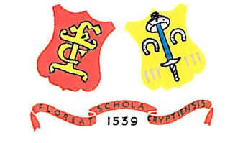

Application for Full Membership

Former pupils of the Crypt School, Gloucester are cordially invited to become full Members of the Old Cryptians’ Club.

I wish to join the Old Cryptians’ Club (OCC) at an annual subscription rate of £25. (A free membership scheme exists for under-21s. Free membership is also extended to present or former members of staff, and to those who qualify for Associate or Life status.)

Name: .................................................................. (Block Capitals please).

Address: ..................................................................

..................................................................

.................................................................

Postcode: .............................

Tel: ....................................... Mobile .......................................

E. Mail address: ..................................................................................

Period at School: From to

Signed .................................Date ................................

Please post this form, when completed, to the Membership Secretary at the address below. Payment should accompany this form – either a cheque in favour of the Old Cryptians Club or a bank transfer to Account 0519048, Sort Code 30-93-48.

Richard Briggs, ‘Avignon’, Ranelagh Drive, Bracknell, Berkshire, RG12 9DA

Tel: 01344 485273 Email: richard.briggs@theiet.org

