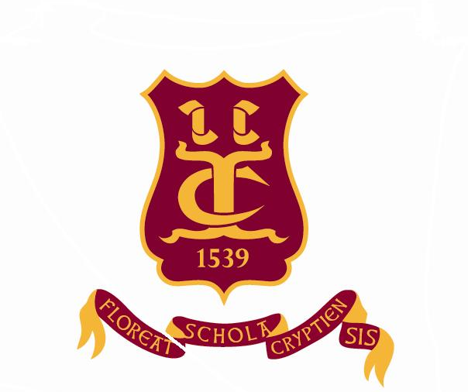
Old Cryptians’ Club
(Founded 1901)

Founders’ Day, Thursday, 29th June 2017 – Reservation Form

Please return this form by Friday, 16th June 2017 to:

Richard Briggs, Avignon, Ranelagh Drive, Bracknell, Berkshire, RG12 9DA
01344 485273 or Richard.Briggs@theiet.org

I should like to attend the Founders’ Day Service in Gloucester Cathedral **

I should like to bring the following guests (3 maximum)

……………………………………………………………………
……………………………………………………………………
……………………………………………………………………
I should like to attend the Founders’ Day Supper in the Parliament Rooms

I should like to bring the following guests (3 maximum)

……………………………………………………………………
……………………………………………………………………
……………………………………………………………………
The cost of the buffet supper (excluding wine, purchased separately) will be £27 for Old Cryptians and their guests.

Name: …………………………………………..

Address: ……………………………………………………………………………

Telephone No: ………………….. Email: ……………………………….

Years at School: From …………... To ………..…

I enclose my cheque (payable to The Old Cryptians’ Club) for £

(Cheques will be banked by the Club Treasurer on or soon after 6th July 2017.)

OR

I should like to pay via BACS or similar

(The Old Cryptians’ Club account details are:
Sort Code 30-93-48 Account Number 00519048)

When making payment, please ensure that you show “OC Supper” in the reference section, so that the payment can be easily identified. Please pay promptly and no later than 19th June 2017. If you choose this payment method, please advise Richard Briggs, either by posting the completed form or emailing the requested information.

This is always a popular event so early booking is advised.

Finally, don’t forget the Golf Competition to be held on the morning of Founders’ Day. Please contact Bob Timms directly for further details. Eric Stephens: 01452 529000 or ericstephens1939@gmail.com

** If you are not intending to come to the Supper, you could, alternatively, inform Sue Wales (Headmaster’s PA) directly on 01452 530291

