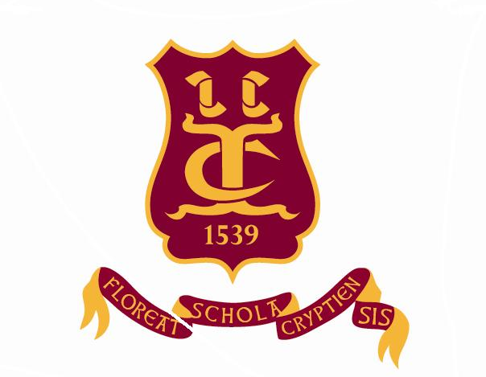
Old Cryptians’ Club
(Founded 1901
OLD CRYPTIAN’ S ANNUAL GOLF DAY
for the THE TONY BEARD CUP
THURSDAY 29TH JUNE 2017
at RODWAY HILL GOLF CLUB, HIGHNAM

FIRST TEE 10.30 PLEASE ARRIVE EARLY FOR COFFEE AND BACON ROLLS
18 HOLE STABLEFORD FOLLOWED BY LUNCH AND PRIZE - GIVING
Please make every effort to join us in a memorable day – meeting old school pals and an enjoyable game of golf. Guests are welcome to attend the day, with a prize for the best score.

TOTAL COST FOR THE DAY £ 25
MAXIMUM HANDICAP ALLOWANCE 24
NORMAL GOLF COURSE DRESS CODE PLEASE

PLEASE CONTACT ERIC STEPHENS BY JUNE 22ND IF YOU ARE ABLE TO ATTEND:
01452 529000 or ericstephens1939@gmail.com

